## **Process Scheduling**

The process scheduling is the activity of the process manager that handles the removal of the running process from the CPU and the selection of another process on the basis of a particular strategy.

Process scheduling is an essential part of a Multiprogramming operating systems. Such operating systems allow more than one process to be loaded into the executable memory at a time and the loaded process shares the CPU using time multiplexing.

## **Categories of Scheduling**

There are two categories of scheduling:

1. **Non-preemptive:** Here the resource can’t be taken from a process until the process completes execution. The switching of resources occurs when the running process terminates and moves to a waiting state.
2. **Preemptive:** Here the OS allocates the resources to a process for a fixed amount of time. During resource allocation, the process switches from running state to ready state or from waiting state to ready state. This switching occurs as the CPU may give priority to other processes and replace the process with higher priority with the running process.

## **Process Scheduling Queues**

The OS maintains all Process Control Blocks (PCBs) in Process Scheduling Queues. The OS maintains a separate queue for each of the process states and PCBs of all processes in the same execution state are placed in the same queue. When the state of a process is changed, its PCB is unlinked from its current queue and moved to its new state queue.

The Operating System maintains the following important process scheduling queues −

* **Job queue** − This queue keeps all the processes in the system.
* **Ready queue** − This queue keeps a set of all processes residing in main memory, ready and waiting to execute. A new process is always put in this queue.
* **Device queues** − The processes which are blocked due to unavailability of an I/O device constitute this queue.

The OS can use different policies to manage each queue (FIFO, Round Robin, Priority, etc.). The OS scheduler determines how to move processes between the ready and run queues which can only have one entry per processor core on the system; in the above diagram, it has been merged with the CPU.

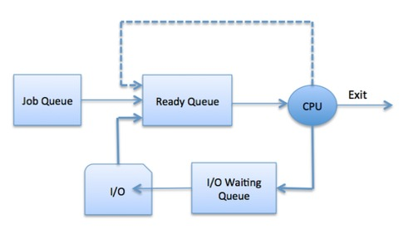

## **Schedulers**

Schedulers are special system software which handle process scheduling in various ways. Their main task is to select the jobs to be submitted into the system and to decide which process to run. Schedulers are of three types −

* Long-Term Scheduler
* Short-Term Scheduler
* Medium-Term Scheduler

## **Long Term Scheduler**

It is also called a **job scheduler**. A long-term scheduler determines which programs are admitted to the system for processing. It selects processes from the queue and loads them into memory for execution. Process loads into the memory for CPU scheduling.

The primary objective of the job scheduler is to provide a balanced mix of jobs, such as I/O bound and processor bound. It also controls the degree of multiprogramming. If the degree of multiprogramming is stable, then the average rate of process creation must be equal to the average departure rate of processes leaving the system.

On some systems, the long-term scheduler may not be available or minimal. Time-sharing operating systems have no long term scheduler. When a process changes the state from new to ready, then there is use of long-term scheduler.

## **Short Term Scheduler**

It is also called as **CPU scheduler**. Its main objective is to increase system performance in accordance with the chosen set of criteria. It is the change of ready state to running state of the process. CPU scheduler selects a process among the processes that are ready to execute and allocates CPU to one of them.

Short-term schedulers, also known as dispatchers, make the decision of which process to execute next. Short-term schedulers are faster than long-term schedulers.

## **Medium Term Scheduler**

Medium-term scheduling is a part of **swapping**. It removes the processes from the memory. It reduces the degree of multiprogramming. The medium-term scheduler is in-charge of handling the swapped out-processes.

A running process may become suspended if it makes an I/O request. A suspended processes cannot make any progress towards completion. In this condition, to remove the process from memory and make space for other processes, the suspended process is moved to the secondary storage. This process is called **swapping**, and the process is said to be swapped out or rolled out. Swapping may be necessary to improve the process mix.

## **Comparison among Scheduler**

|  |  |  |  |
| --- | --- | --- | --- |
| **S.N.** | **Long-Term Scheduler** | **Short-Term Scheduler** | **Medium-Term Scheduler** |
| 1 | It is a job scheduler | It is a CPU scheduler | It is a process swapping scheduler. |
| 2 | Speed is lesser than short term scheduler | Speed is fastest among other two | Speed is in between both short and long term scheduler. |
| 3 | It controls the degree of multiprogramming | It provides lesser control over degree of multiprogramming | It reduces the degree of multiprogramming. |
| 4 | It is almost absent or minimal in time sharing system | It is also minimal in time sharing system | It is a part of Time sharing systems. |
| 5 | It selects processes from pool and loads them into memory for execution | It selects those processes which are ready to execute | It can re-introduce the process into memory and execution can be continued. |

## **Context Switching**

A context switching is the mechanism to store and restore the state or context of a CPU in Process Control block so that a process execution can be resumed from the same point at a later time. Using this technique, a context switcher enables multiple processes to share a single CPU. Context switching is an essential part of a multitasking operating system features.

When the scheduler switches the CPU from executing one process to execute another, the state from the current running process is stored into the process control block. After this, the state for the process to run next is loaded from its own PCB and used to set the PC, registers, etc. At that point, the second process can start executing.

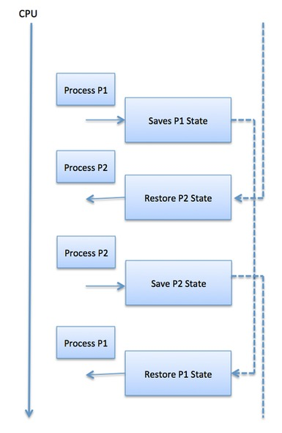

Context switches are computationally intensive since register and memory state must be saved and restored. To avoid the amount of context switching time, some hardware systems employ two or more sets of processor registers. When the process is switched, the following information is stored for later use.

* Program Counter
* Scheduling information
* Base and limit register value
* Currently used register
* Changed State
* I/O State information
* Accounting information